PEC System User Manual
- Introduction
- System Overview
- Getting Started
- User Roles and Permissions
- Module Descriptions
- Detailed Feature Guides
- Troubleshooting
- Security Guidelines
- Frequently Asked Questions

1. Introduction <a name="introduction"></a>
Welcome to the Punjabi Education Center (PEC) Management System. This comprehensive platform is designed to streamline operations for Punjabi education centers across Malaysia, providing tools for administration, student management, financial tracking, and reporting.

1.1 Purpose
The PEC System helps education center administrators efficiently manage:
- User accounts and permissions
- Center information and details
- Board members and governance
- Teacher records and qualifications
- Student enrollment and class management
- Financial transactions and reporting
- Analytics and regulatory compliance

1.2 System Requirements
- Modern web browser (Chrome, Firefox, Safari, Edge)
- Internet connection
- Screen resolution of 1024x768 or higher recommended

2. System Overview <a name="system-overview"></a>
The PEC System is a web-based application with a responsive design that works on both desktop and mobile devices. The interface is divided into:
- Navigation Sidebar: Access to all system modules
- Main Content Area: Displays the active module content
- User Information Bar: Shows current user details

2.1 Interface Components
- Top Navigation: User info and mobile menu toggle
- Sidebar: Permanent navigation on desktop, collapsible on mobile
- Content Area: Dynamic content based on selected module
- Action Buttons: Context-specific actions (Add, Edit, Delete, etc.)

3. Getting Started <a name="getting-started"></a>

3.1 Accessing the System
- Open your web browser
- Navigate to the PEC System URL
- The login screen will appear

3.2 Logging In
- Enter your User ID (provided by your administrator)
- Enter your Password (case-sensitive)
- Select your PEC Code from the dropdown
- Click the "Login" button

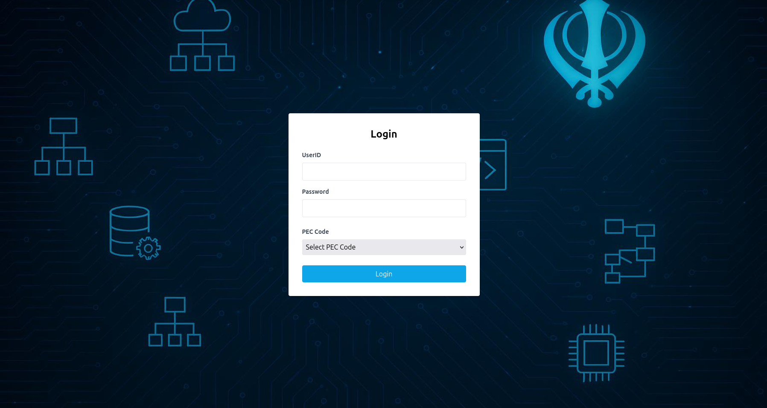
Fig. 1: Login screen with credentials input fields

Note: All login credentials are case-sensitive. If you've forgotten your password, contact your system administrator.
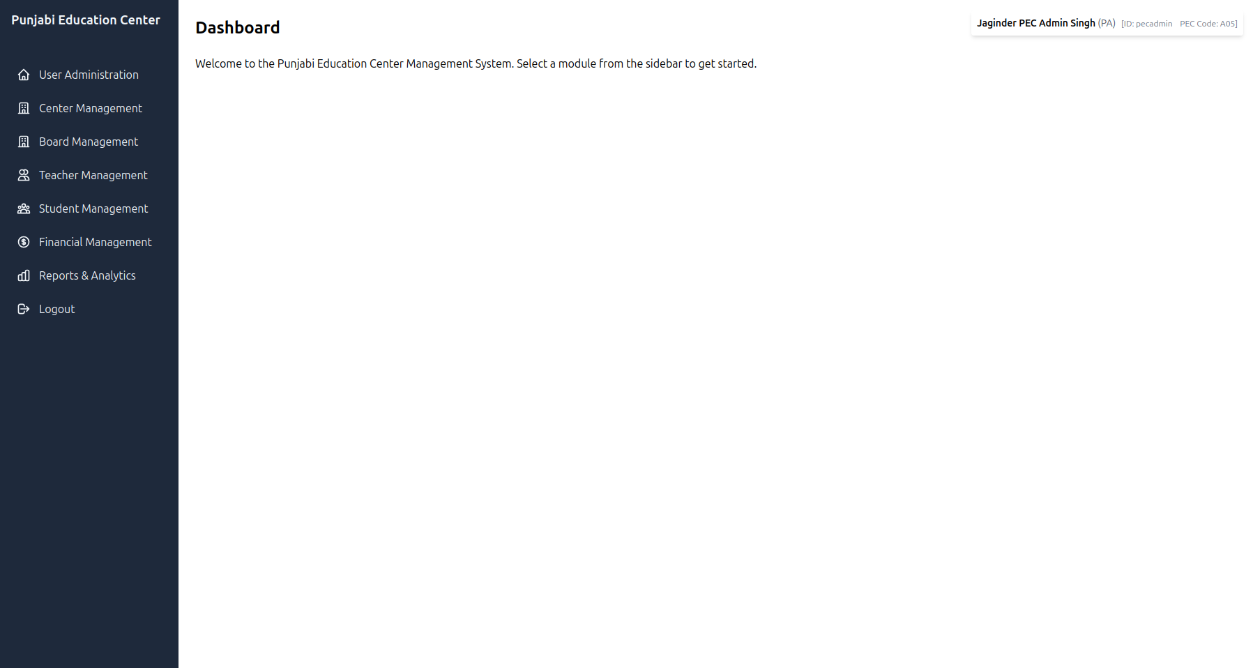
Fig. 2: Main dashboard after successful login

3.3 First-Time Login
If this is your first time logging in:
- You may be prompted to change your password
- Familiarize yourself with the dashboard and navigation
- Review your user permissions

3.4 Logging Out
To log out of the system:
- Click on the "Logout" option in the sidebar
- Alternatively, close your browser window (session will timeout after inactivity)

4. User Roles and Permissions <a name="user-roles-and-permissions"></a>
The system has three primary user roles with different permission levels:

4.1 PEC Admin (PA)
- Full system access across all centers
- Can manage all users, centers, and data
- Access to all reporting functions
- System configuration capabilities

4.2 Center Admin (CA)
- Management capabilities for their assigned center only
- Can manage users within their center
- Access to center-specific data and reports
- Cannot access other centers' information

4.3 Normal User (NM)
- Limited to viewing their own information
- Restricted access to system functions
- Typically teachers or administrative staff with limited needs
Fig. 3: User roles and their access permissions

5. Module Descriptions <a name="module-descriptions"></a>

5.1 Dashboard
The landing page after login provides an overview and quick access to common tasks.

5.2 User Administration
Manage system users, their roles, and permissions. Accessible to PA and CA roles.

Fig. 4: User administration interface

5.3 Center Management
Create and maintain education center profiles, including address and banking information.

5.4 Center Board Management
Record and manage board member details for each education center.

5.5 Teacher Management
Maintain comprehensive records of teaching staff, including qualifications and contact information.
https://via.placeholder.com/800x450.png?text=Teacher+Management+Module
Fig. 5: Teacher management interface

5.6 Student Management
Manage student enrollment, class assignments, and parent/guardian information.

5.7 Financial Management
Track income and expenses, generate financial reports, and manage transactions.
https://via.placeholder.com/800x450.png?text=Financial+Management+Module
Fig. 6: Financial management dashboard

5.8 Reports & Analytics
Generate various reports for operational, financial, and regulatory purposes.

6. Detailed Feature Guides <a name="detailed-feature-guides"></a>

6.1 User Administration

Adding a New User
- Navigate to User Administration
- Click "Add New User"
- Fill in all required fields:
  - User ID (max 10 characters)
  - User Name (max 50 characters)
  - Password (max 15 characters)
  - Role (based on your permissions)
  - Status (Active/Inactive)
- Click "Add User" to save
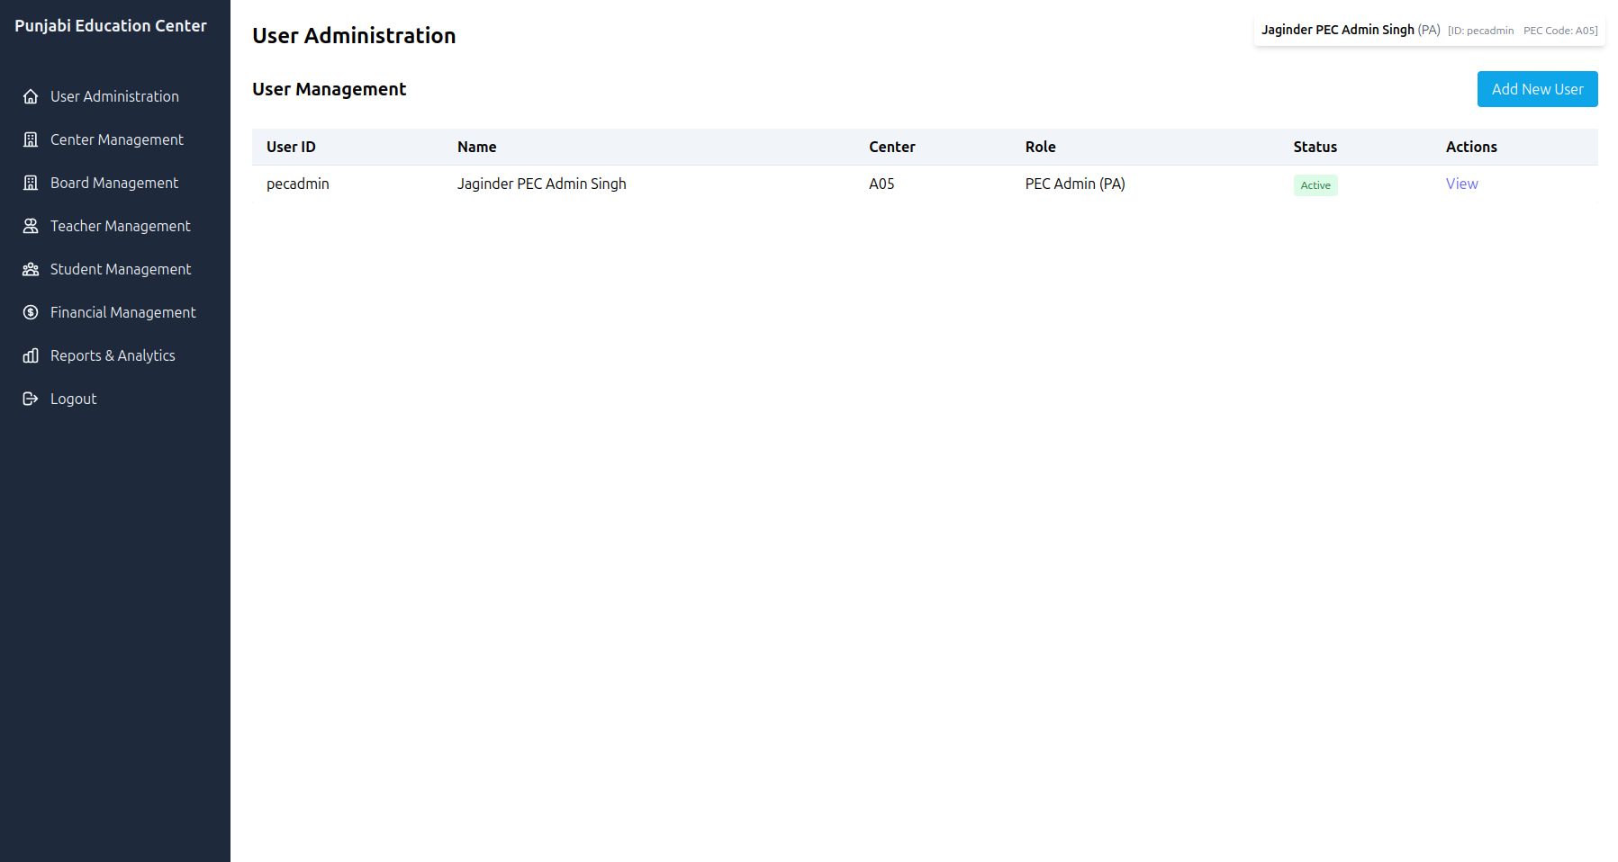
Fig. 7: Add new user form
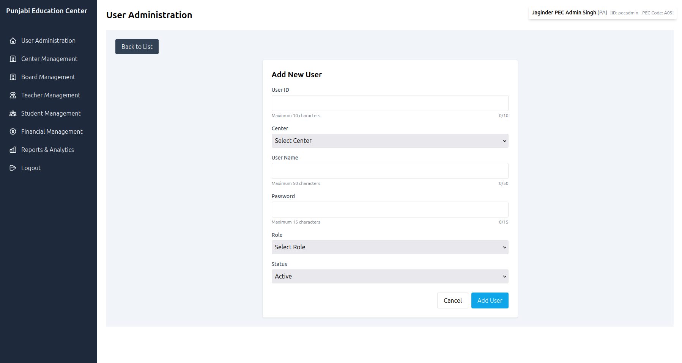

Editing a User
- From the user list, click "View" next to the user
- Click "Edit" in the detail view
- Make necessary changes
- Click "Update User" to save changes
Note: User IDs cannot be changed after creation.
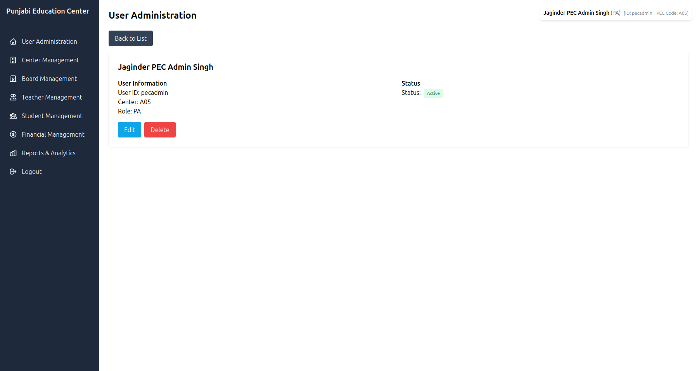
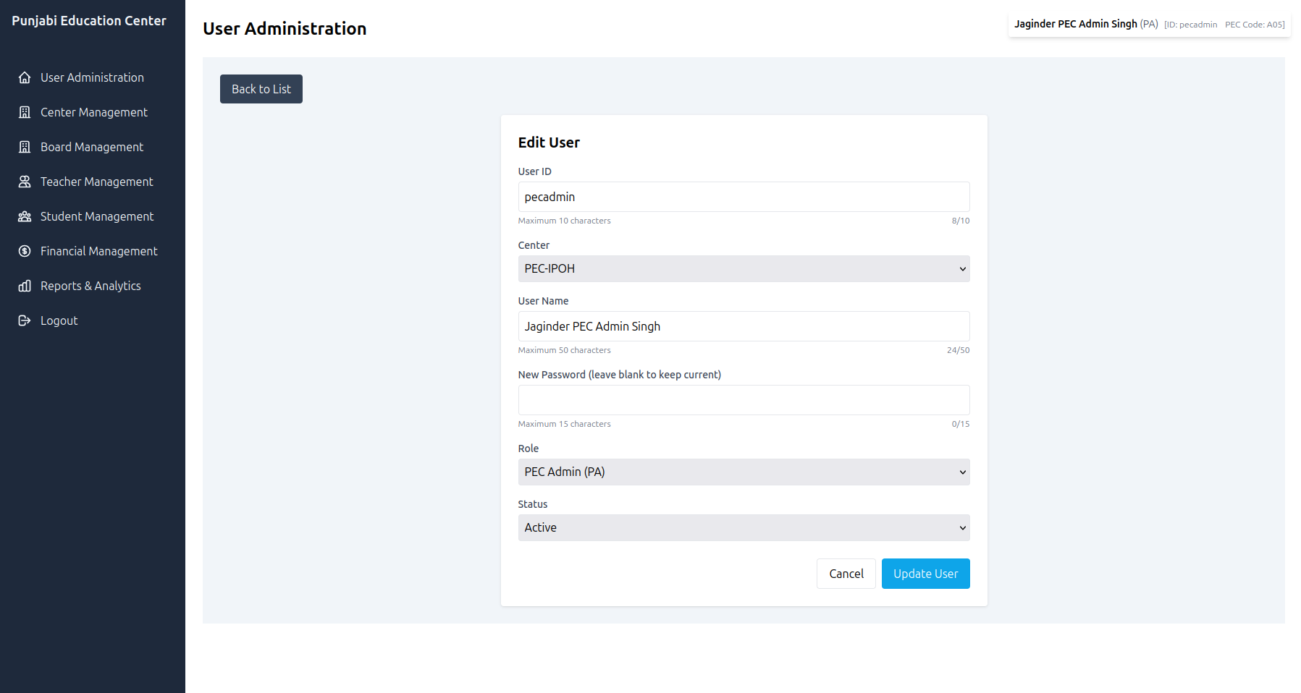

6.2 Center Management

Adding a New Center (PA only)
- Navigate to Center Management
- Click "Add New Center"
- Complete center details:
  - PEC Code (unique identifier)
  - Center Name
  - ROS Number
  - Operating Days and Times
  - Banking Information
- Add address details
- Click "Save Center"

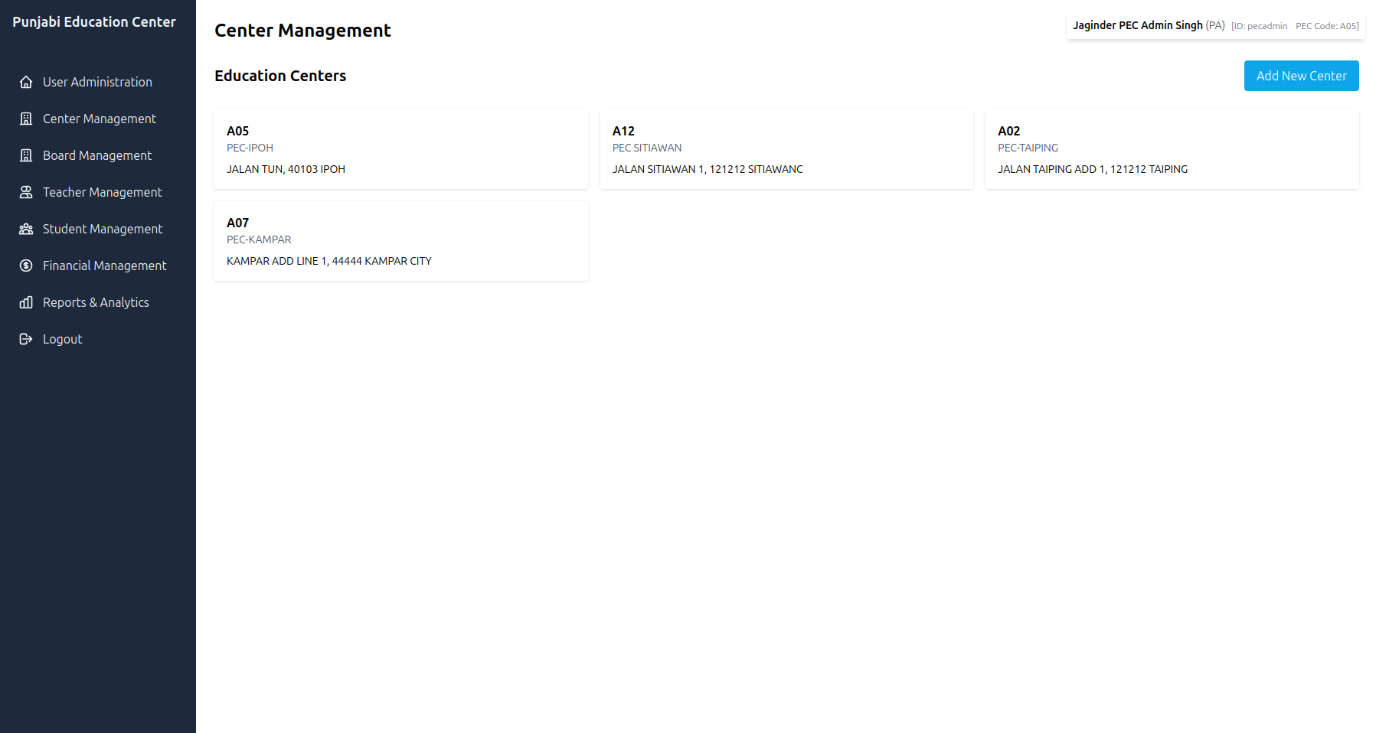
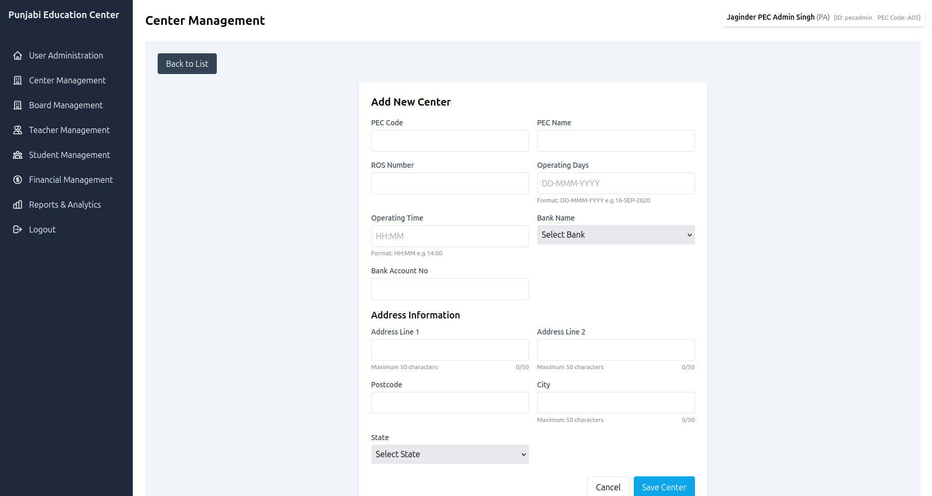

Editing Center Information
- Click on a center card to view details
- Click "Edit"
- Update the necessary information
- Click "Save Center"
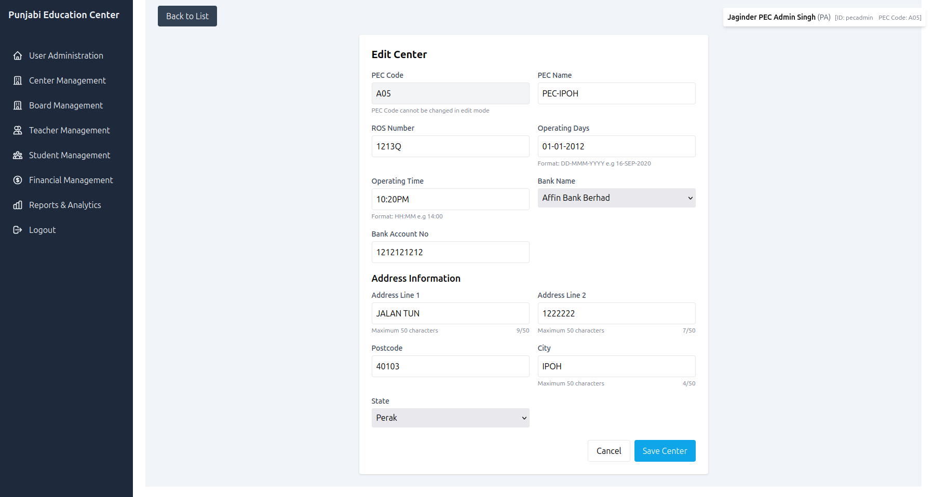

6.3 Board Member Management

Adding a Board Member
- Navigate to Center Board Management
- Click "Add New Board Member"
- Fill in personal details:
  - Name, IC Number, Gender
  - Contact Information
  - Position
- Add address information
- Set status (Active/Inactive)
- Click "Save Board Member"

6.4 Teacher Management

Adding a Teacher
- Navigate to Teacher Management
- Click "Add New Teacher"
- Complete teacher profile:
  - Personal information
  - Contact details
  - Qualifications and experience
  - Current employment status
- Add address information
- Click "Save Teacher"

6.5 Student Management

Enrolling a New Student
- Navigate to Student Management
- Click "Add New Student"
- Fill in student details:
  - Personal information
  - Class assignment
  - Parent/guardian details (at least one required)
  - Household information
- Add address details
- Click "Save Student"
https://via.placeholder.com/800x450.png?text=Student+Enrollment+Form
Fig. 8: Student enrollment form

Class Assignment
When adding or editing a student, select the appropriate class from the dropdown menu. Classes are predefined in the system.

6.6 Financial Management

Recording a Transaction
- Navigate to Financial Management
- Click "Add New Transaction"
- Select account type (Income/Expense)
- Enter transaction date
- Input amount (max 8 digits)
- Add comments if needed
- Click "Save Transaction"

Viewing Financial Summary
The financial dashboard displays:
- Total Income
- Total Expenses
- Net Amount
- Filtering by year

6.7 Reports & Analytics

Generating Reports
- Navigate to Reports & Analytics
- Select report type
- Apply filters as needed:
  - PEC Center (for PA users)
  - Class (for student reports)
- Click "Generate Report"
- Use "Export to CSV" to download data
https://via.placeholder.com/800x450.png?text=Reports+and+Analytics
Fig. 9: Reports generation interface

Available Reports
- Student & Class Record (Detailed)
- Student & Class Record (Summary)
- Statement of Income
- Teacher Records
- PEC Records

7. Troubleshooting <a name="troubleshooting"></a>

7.1 Common Issues

Login Problems
- Ensure all credentials are entered correctly (case-sensitive)
- Verify you've selected the correct PEC Code
- Check that your account is active (contact administrator if unsure)

Slow Performance
- Check your internet connection
- Close unnecessary browser tabs
- Clear browser cache if issues persist

Data Not Saving
- Ensure all required fields are completed
- Check for validation messages
- Verify you have permission to perform the action

7.2 Error Messages

"Invalid username or password"
- Check capitalization of credentials
- Ensure correct PEC Code is selected
- Contact administrator if issues persist

"Permission Denied"
- Your user role doesn't allow this action
- Contact administrator if you need elevated permissions

"Database Error"
- System issue - try again later
- Contact technical support if problem continues

8. Security Guidelines <a name="security-guidelines"></a>

8.1 Password Management
- Use strong, unique passwords
- Never share your password with others
- Change your password periodically
- Report any suspicious activity immediately

8.2 Data Privacy
- Only access information necessary for your role
- Log out when leaving your workstation
- Don't leave sensitive information displayed on screen
- Follow your organization's data handling policies

8.3 System Access
- Use only authorized devices to access the system
- Avoid public computers for system access
- Ensure your device has updated security software

9. Frequently Asked Questions <a name="frequently-asked-questions"></a>

Q: I forgot my password. What should I do?
A: Contact your system administrator to reset your password.

Q: Why can't I see all centers in the system?
A: Your user role determines which centers you can access. Center Admins can only see their assigned center, while PEC Admins can see all centers.

Q: How do I update my personal information?
A: Users with appropriate permissions can edit your information through User Administration. Normal users can only view their own information.

Q: Why am I getting an error when trying to save a transaction?
A: Ensure the amount doesn't exceed 8 digits and all required fields are completed. Check that you have the necessary permissions.

Q: How often should I back up data?
A: The system automatically handles data backups. However, you should regularly export important reports for your records.

Q: Who should I contact for technical support?
A: Contact your system administrator or the technical support team designated by your organization.

Q: Can I access the system from my mobile device?
A: Yes, the system is responsive and works on mobile devices, though some complex tasks may be easier on a desktop.

Q: How current is the data shown in reports?
A: Reports show real-time data based on the latest information in the system.

Note: This documentation is based on the system as of the last update. Features and interfaces may change with future versions. Always refer to the most current version of this manual or contact your administrator for the latest information.
Confidential: This document and the system it describes contain proprietary information of the Punjabi Education Center management system. Unauthorized distribution is prohibited.
Revision History:
- Version 1.0: Initial user manual
- Version 1.1: Updated with financial management details
- Version 1.2: Added troubleshooting section

